The Bluetooth Sensor/Controller Project
January 2008
This project was motivated by an inquiry on the Microsoft.public.compactframework newsgroup. The gist of the question was, “How can I connect a switch input to my Pocket PC, so that I can detect change-of-state of the switch?” The problem is that Pocket PC’s, in general, and other PC’s, such as some notebook computers have no (or very limited) general-purpose hardware I/O. Thus, it can be hard to connect them to real-world inputs.
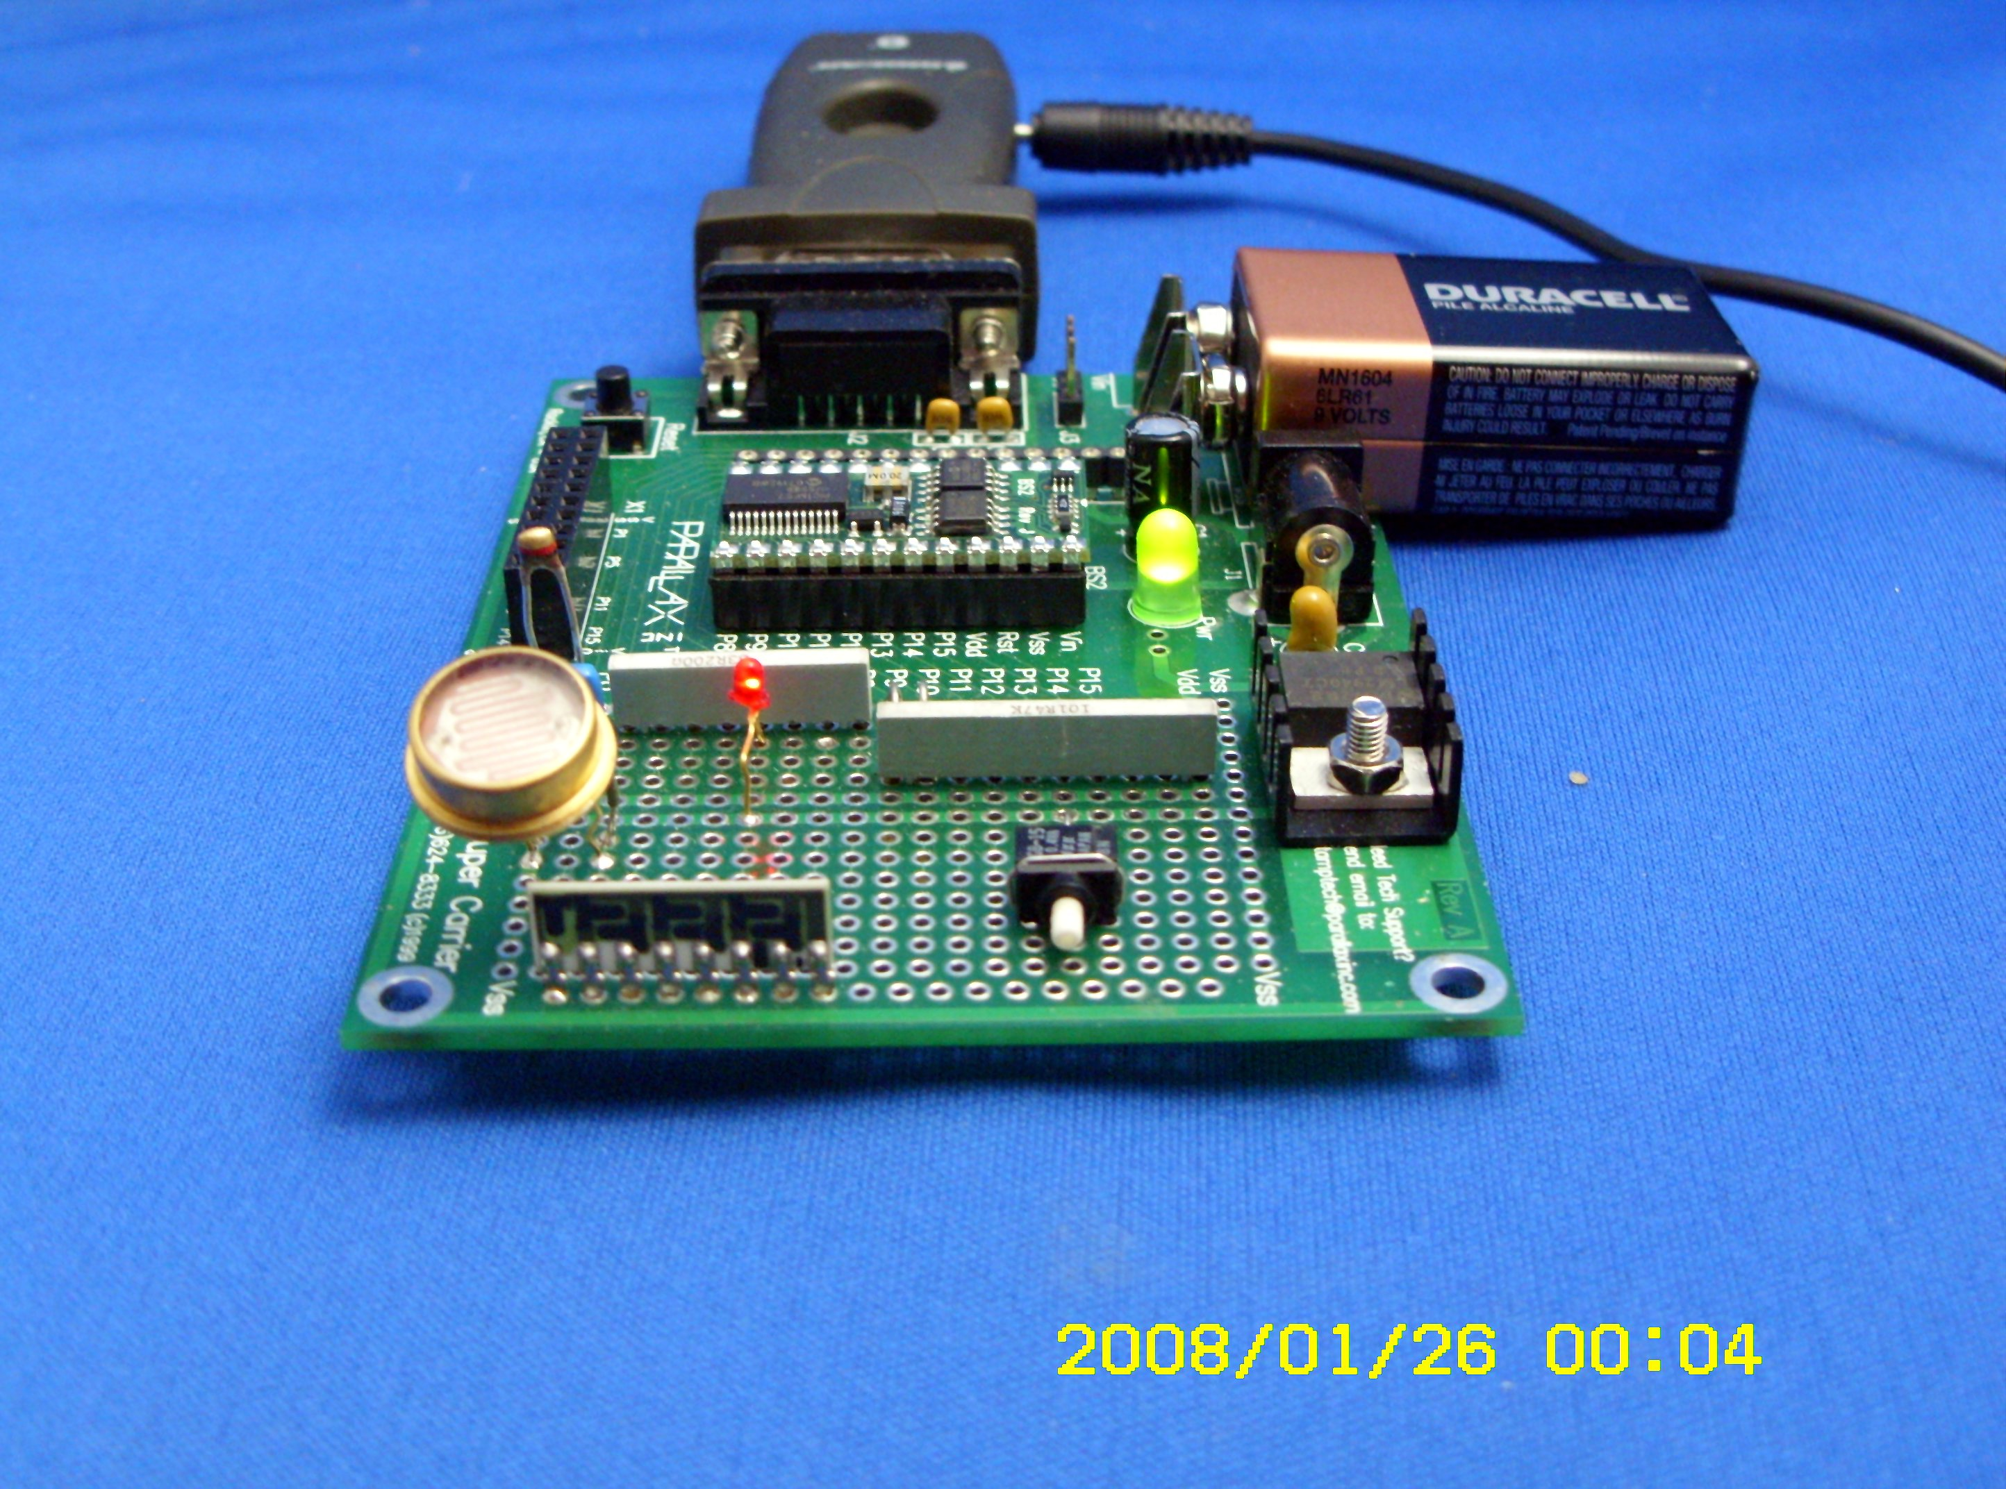
Another issue that makes such I/O problematic is that you have to actually connect wires or a cable between your computer and the sensor… This certainly reduces the portability of the computer.

One thing that many Pocket PCs and notebook computers have is a interface. Bluetooth is an industrial specification for wireless personal area networks (PANs). Bluetooth provides a way to connect and exchange information between devices such as mobile phones, laptops, PCs, printers, digital cameras, and video game consoles over a secure, globally unlicensed short-range radio frequency. The Bluetooth specifications are developed and licensed by the Bluetooth Special Interest Group.
OK, but I don’t see anything in this “official description” of Bluetooth that suggests that Bluetooth is good method to use for this simple – or for other even more complex – applications. And, by itself, that objection is correct. However, if we combine a simple microcontroller board that has a serial communications port, with a serial Bluetooth adapter, we now have a mechanism for sending and receiving wireless data between our Pocket PC or other computer and the microcontroller board. We can use the microcontroller to provide the interface to our sensors (anything from a simple switch to much more complex “stuff”) and also to provide a way for us to send commands and control signals from the computer to the microcontroller!
Let’s start by selecting some off-the-shelf hardware that we can use to realize this project.
There are several commercial Bluetooth serial adapters; in general each is functionally equivalent to the others in this category. Popular manufacturers are Quatech, Socket Communications, IOGear, and more. I chose the IOGear Model GBS 301. It is comparately low cost, about $75, with shipping, and it is readily available. I purchased my adapter though eBay.
There also are OEM Bluetooth interfaces that might be integrated directly into a low-cost solution.
There are dozens of microcontroller boards that might be used. I based by choice on these characteristics.
- Low cost, naturally
- Ease of programming (a BASIC language variant would be ideal)
- Compact form factor
- Simple power requirements (ideally it can be powered from the same power supply as is used by the Bluetooth adapter
I chose the Parallax BASIC Stamp ™ 2 Module ($50) with a BASIC Stamp Super Carrier board ($20) to provide the serial interface circuitry, power supply, and prototyping space for my own circuitry. The simpler BASIC Stamp Carrier Board ($15) also would have worked.
It is hard to predict what sort of hardware sensors or controls might be used in a real-world application of these ideas, so I decided to “keep it simple” and to show how one might interface two different sensor types (two switches for digital input, and two variable resistance sources for analog input – one a thermistor for temperature measurement, and the other a photo-resistor for light measurement). To simulate an output to be controlled from the computer, I chose a LED to turn on and off by command from the computer. Naturally, more complex inputs and outputs may be used in your own application! Total cost of this additional hardware was about $10 – thus, the project cost was on the order of $170, when shipping costs are included.
The BASIC Stamp has 16 I/O ports. For the hardware that I’ve described above, I used four ports to input sensor data, and a single port for output. The documentation that is provided with the BASIC Stamp goes into detail about the electrical interface, so I’ll leave that area alone. The following figures show how each sensor and output was designed and connected to the BS2 module.
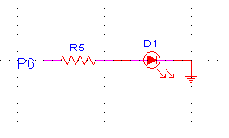Figure 1 (LED Output connected from BS2 Port 6)
R5 = 200 Ω
D1 = small Red LED
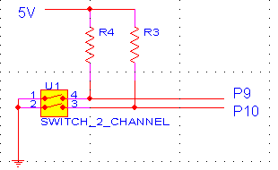Figure 2 (Switch Input to BS2 Ports 9 and 10)
R4 , R5 = 10K Ω
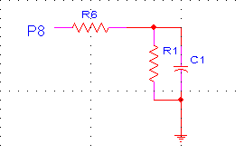Figure 3 (Photo-resistor Input to BS2 Port 8)
R6 = 200 Ω
R1 = 9K – 600K Ω Photo-resistor, CL5M5
C1 = 0.01 µF
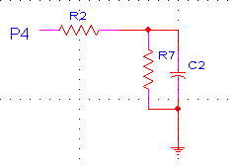Figure 4 (Thermistor Input to BS2 Port 4)
R2 = 200 Ω
R7 = 1K Ω Thermistor, NTC
C1 = 0.1 µF
I considered adding a PIRM Passive InfraRed detection Module (AMP 180-200), but decided that the point had already been made. Had I done so, the schematic for this detector would have been quite simple, and is shown in the next figure.
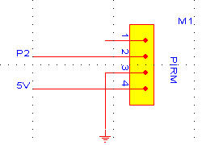Figure 5 (PIRM Input to BS2 Port 2)
The PIRM 180-200 infrared module is a compact 180° field of view motion sensor. This provides the user with a digital active high output indicating when the sensor has detected motion within a range of 20 feet.

Microcontroller Code
Writing and debugging code for the Parallax BS2 is straight forward. Download the BASIC Stamp Editor (IDE) from Parallax. Connect a PC serial port to the Carrier Board with the BS2 module installed in the socket provided. Connect power to the Carrier Board (use a 9V battery, or connect to a 6V or higher supply). Write your programs and download them to the BS2 for testing. The instructions and examples provided by Parallax illustrate the process, and a few minutes should get you going.
The BASIC language syntax used will seem both familiar and alien. It is much more terse than VB, and structured more like the original forms of BASIC (GOTO labelname is encouraged, not discouraged; simple subroutines are the only structured elements). We need to recognize that the goal of our microcontroller programming is utility over form – and the BASIC language that is provided is utilitarian.
Here is a view of the BASIC Stamp IDE.
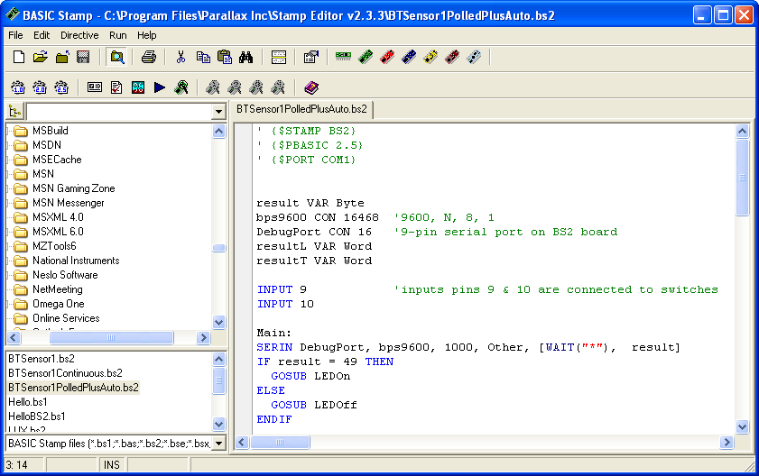
Figure 6 Basic Stamp Editor (IDE)
The Carrier Board has a 9-pin RS232 female connector that we use for BS2 programming and debug from the BASIC Stamp Editor. This port also is the one that we will use to connect out Bluetooth adapter. Because Parallax uses some hardware handshaking lines to identify the BS2 (and during programming) that are not supported by the Bluetooth adapter, all programming and debugging should be done using a standard RS232 adapter – this can employ either a standard RS232 port, or a USB serial adapter. Once a program has been debugged using standard hardware, the Bluetooth adapter can be substituted for the cable connection to provide the “real-world” wireless connection between sensor/controller and our Pocket PC or other computer.
Before beginning programming, it would be appropriate to create a serial protocol that will support the data and commands that we will be employing. This protocol need not be complex – and the one that I’ve created is quite simple – but it should be flexible enough to be expanded to meet whatever may be needed in the future. Naturally, the actual hardware that we are employing creates and upper boundary on the complexity of this future.
The Serial Protocol
Commands may be sent from the host computer. I have only one thing to control (the red LED on the microcontroller board may be turned on or off), so the command structure can be simple. I chose to use an ASCII (all text) protocol to make things as easy as possible.
Command | Data | Terminator | Remark
* | 1 | none | Turn LED on
* | 0 | none | Turn LED off
* | Any other alphanumeric character | none | Undefined. However, this allows us to add numerous commands to affect other microcontroller functions

A command string from host computer to controller will look like this:
“*1”
Or
“*0”
The response protocol from the microcontroller to the host computer also is simple. I’ve enhanced responses to add both a Response type character and a Terminating character – so responses can be of variable length. Here is that part of the protocol.
Response Character | Data | Terminator | Remark
S | 1|0,1| | Carriage Return [13] | Switch 1 on = 0, off = 1 (active Low logic)
S | 2|0,1| | Carriage Return [13] | Switch 2 on = 0, off = 1 (active Low logic)
L | Value |0-65535| | Carriage Return [13] | Light level, measured by change of resistance in the sensor. Practical measurements will range from 1 (very bright illumination) to perhaps 50000 (very little illumination)
T | Value |0-65535| | Carriage Return [13] | Temperature measured by a change of resistance in the sensor will range from 35 (about 50° C), 54 (about 24° C) to perhaps 76 (about 0° C)

So, for example a response string of “T54” & vbCr represents a temperature of approximately 24° C. A response string of “L144” & vbCr indicates low intensity lighting, perhaps about 30 LUX. A response string of “S10” & vbCr indicates that switch 1 is closed, while “S21” & vbCr indicates that switch 2 is open. Temperature and light levels are not calibrated, and the range of values is non-linear. Linearization should be done on the host computer – these techniques are well described elsewhere.
Here is BASIC Stamp code that implements the hardware interface and serial protocol.
This code consists of two main processes. First, variables are defined that a used later in the code. Next, BS2 port pins 9 and 10 are defined as inputs. Then, the Main processing loop is entered (label Main:).
In the Main processing loop, the serial port is polled to see if a command has been received. This polling uses the SERIN statement with a timeout if no data have been received. If data are received before the 1000 mS timeout, then those two bytes (only two bytes are allowed in the SERIN statement, and the first character must be a “*” – the second characters is the actual command) are processed. If the command character is an ASCII 1 (decimal value 49), then the LED is lit, while if it is an ASCII 0 (decimal value 48) then the LED is extinguished. If some other command character is received, the entire command is ignored. The possibility that other characters might be received allows this command interpreter to be expanded in the future.
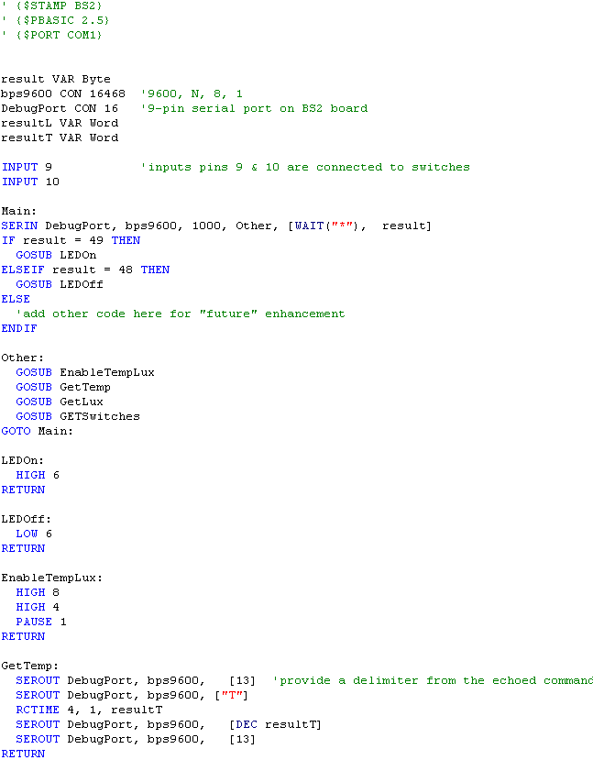
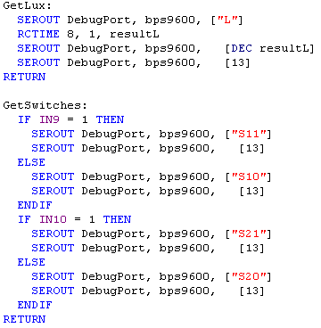
After a command has been processed, execution continues with the label Other:. This code configures ports 4 and 8 for resistance measurement; it then calls subroutines in sequence to output sensor status. The first subroutine tests switch state on ports 9 & 10 and reports their state. Next, the resistance of the thermistor is measured and that value reported, then the resistance of the photo-resistor is measured and reported. When all sensor states have been reported, the polling loop resumes at Main:.
If no valid commands are received before the 1000 mS timeout of the SERIN statement, the timeout results in calling the sensor status routines (Other: label) directly. Thus, in absence of a command, the microcontroller reports its sensor status automatically every 1000 mS. What this means is that the host program can simply monitor and interpret data from the sensors, whether or not a command has been issued. If a command is issued, sensor status is reported immediately. By extending the SERIN timeout parameter, this automatic reporting interval can be a frequent or infrequent as desired. Of course, automatic reporting is a feature that can be skipped entirely, too.
Using the Bluetooth Serial Adapter
The Bluetooth adapter has a set of dipswitches that configure mode and serial speed. The default mode (slave) and speed (9600 bps) are fine for our application. While the adapter supports higher serial speeds, these are not needed and might burden the microcontroller, making operation less reliable.
There is one important hardware consideration when using the IOGear BT adapter (this may or may not be true on other adapters). The IOGear adapter employs hardware flow control. Thus, CTS (Clear To Send) must be raised (High on the RS232 interface) for it to output data that has been received from the host computer. The BS2 serial interface does not connect the CTS pin, so it should be connected to RTS at the 9-pin serial connector on the Carrier Board. Connect pins 7 and 8 together to assure receipt of data.
Connect power to the Bluetooth adapter, and follow the manufacturer’s instructions for pairing the adapter with your host computer (Pocket PC or other). The following figures show these steps. Figures 7 & 8 illustrate this on a Dell Axim X51v Pocket PC.
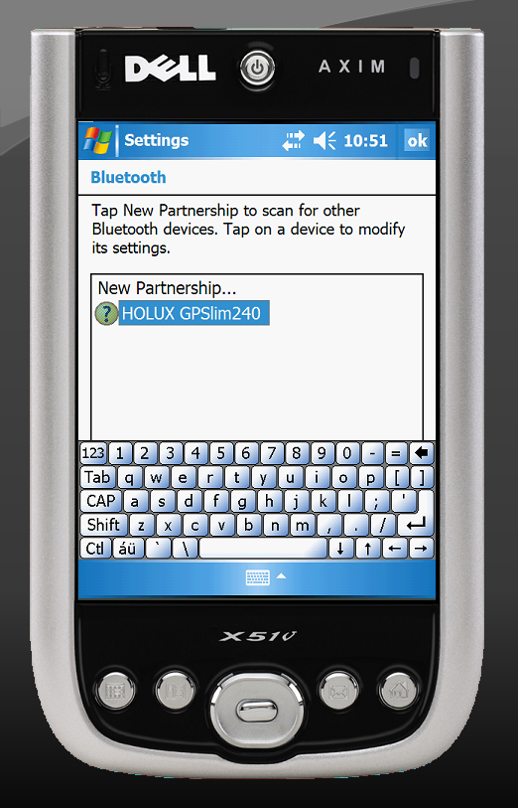
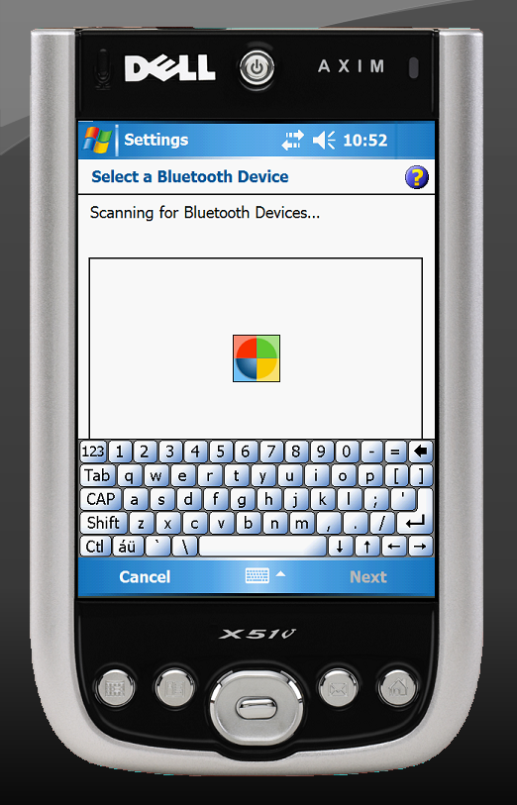
Figure 7 Pairing Steps 1 & 2

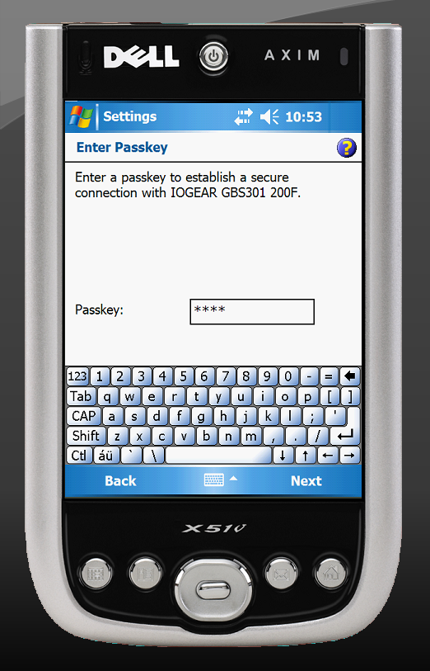
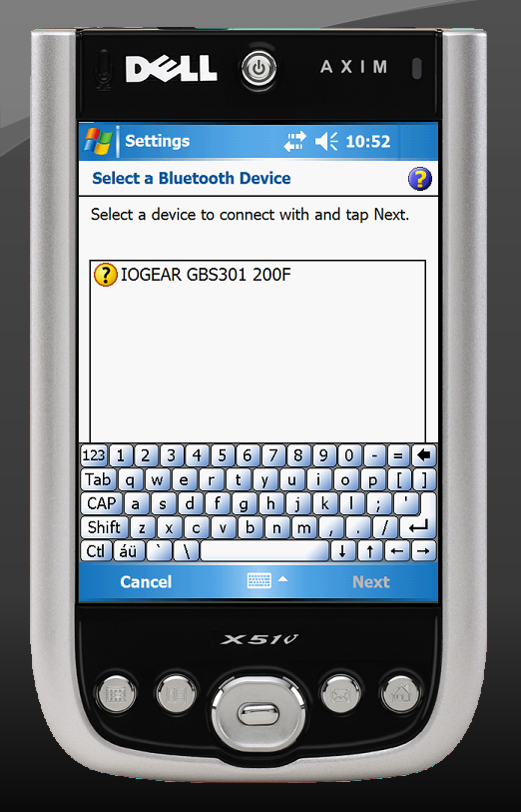
Figure 8 Pairing Steps 3 & 4
Once pairing has been completed, it is possible to write and debug Compact Framework code that uses the Bluetooth Virtual Serial Port (SPP) that these steps have created. Figure 9 shows a simple application in action.

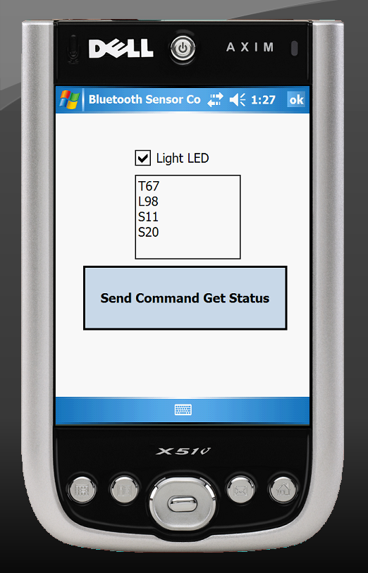

Figure 9 A Compact Framework Application
Check the Light LED checkbox and click the Send Command Get Status button to light the LED on the microcontroller board and to view sensor data in the text box. Likewise, uncheck the Light LED checkbox and click the Send Command Get Status button to extinguish the LED on the microcontroller board and to view sensor data in the text box.
In all of the host computer programs, you would want to add additional parsing to actually interpret the sensor data in a more complete way.
Pairing the Bluetooth serial adapter with a desktop/notebook or similar computer would be done in a similar way to that for the Pocket PC. Follow the steps described in the Bluetooth adapter documentation. The following figures show that process for such a host.
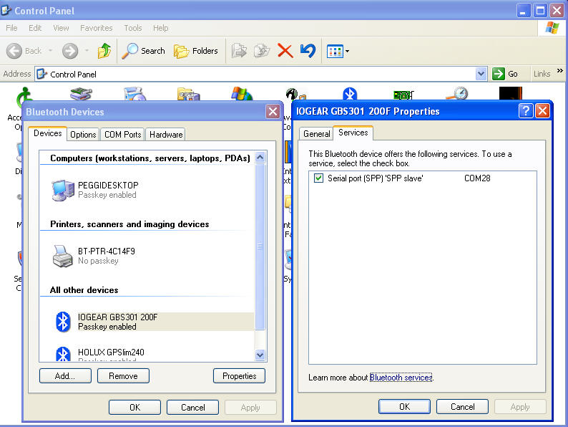
Figure 10 Bluetooth Pairing on a Desktop or Notebook computer
Once paired, you can write a host application using your language and environment of choice. The following figure shows host applications written in Visual Basic 2005 and VB6, respectively.
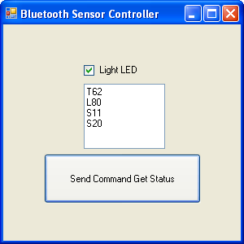
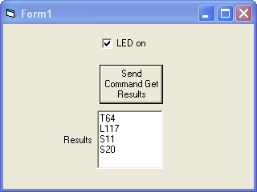
Figure 11 Desktop Host Programs

Complete source code for these examples, and more extensive BASIS Stamp examples are included on the CDROM that accompanies my book, Visual Basic Programmer’s Guide to Serial Communications, 4th Edition. See the Books link on www.hardandsoftware.net for more information.

