Low-speed Serial Data Acquisition using the DATAQ DI-194RS
Copyright © Richard L. Grier, 2009
Hard & Software
www.hardandsoftware.net
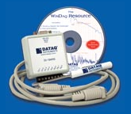
The DATAQ DI-194RS is a low-cost serial data acquisition device. It offers sample rates of 60, 120, or 240 samples/second when using 4, 2 or 1 analog channel(s). The full 240 Hz sample rate is only available if you use a single channel. Data are acquired with 10-bit resolution. There also are 2 digital inputs and one digital I/O connection (see the DIO limitation notes).
The DI-194RS is sold as a “starter kit” for $24.95 + s/h. The kit consists of the A/D box, a 9-pin serial cable, and WinDAQ “Lite” software on the CDROM.
The WinDAQ “Lite” software is limited to using the built-in UI for control and display, and the sample rate is limited to 60 Hz, with all four channels active. Data may be recorded to a disk file, but there is no programmatic interface (API) in WinDAQ.
Figure 1 shows the furnished WinDAQ software with a 6 Hz input on CH1. WinDAQ Lite software is fine for some purposes, but most users will need to have more control over the way that data are acquired and displayed. Thus, most of us need an API so that we can craft a custom application.
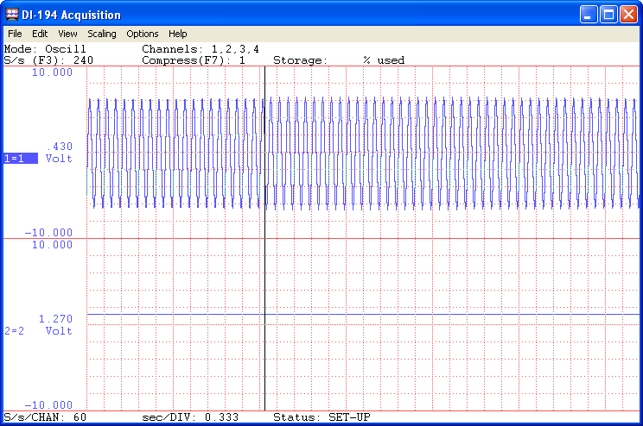
Figure 1. WinDAQ Lite
Custom Software
There are two ways to employ DATAQ A/D’s from you own software.
- Programming language tools are available via the DATAQ website. These consist of ActiveX controls for most of their hardware (see: http://www.dataq.com/products/software/activex.htm).
- You can employ the WinDAQ Starter Kit Instruments Raw Data Format description (see: http://www.dataq.com/support/techinfo/dataform.htm) to write your own routines to use these devices. I’ve reproduced the appropriate section of this document below for the DI-194RS. Note, the information that DATAQ provides here is “unsupported,” terse and incomplete (my analysis). While they say that a variety of programming language examples are provided, these employ a Windows dll, and use in a modern programming environment , such as Visual Studio 2008 (.NET) is not illustrated by DATAQ.
Why might one want to employ the details in the “Raw Data Format,” rather than using an ActiveX control? First, if using .NET, you might prefer to write code that is self-contained, and that does not employ an OCX and the required wrapper .NET wrapper assembly (Interop dll). Second, and my actual motivation, you might want to write code for the .NET Compact Framework, so that you could interface to a compact device, such as a Pocket PC or WinCE client. The Compact Framework cannot use Win32 ActiveX controls, so writing low-level code is the only option.

T194 Encryption Table of WinDaq Starter Kit DI-194
All the info provided here is "AS IS", please do not email DATAQ for further support/explanation
Table1 | B7 | B6 | B5 | B4 | B3 | B2 | B1 | B0
Byte1 | A4 | A3* | A2* | A1* | D2/A0* | D1 | D0 | 0
Byte2 | A11 | A10 | A9 | A8 | A7 | A6 | A5 | 1¹
Byte3 | B4 | B3* | B2* | B1* | D2/B0* | D1 | D0 | 1
Byte4 | B11 | B10 | B9 | B8 | B7 | B6 | B5 | 1^{1,2}
Byte5 | C4 | C3* | C2* | C1* | D2/C0* | D1 | D0 | 1
Byte6 | C11 | C10 | C9 | C8 | C7 | C6 | C5 | 1¹
Byte7 | E4 | E3* | E2* | E1* | D2/E0* | D1 | D0 | 1
Byte8 | E11 | E10 | E9 | E8 | E7 | E6 | E5 | 1¹
Notes | * 194RS uses bit 11 to bit 2  Ax is the xth bit of ADC reading from channel one  Bx is the xth bit of ADC reading from channel two if enabled  Cx is the xth bit of ADC reading from channel three if enabled  Ex is the xth bit of ADC reading from channel four if enabled  Dx are the digital input bits  - This bit is 0 when a single channel is selected (240 Hz sample rate)  - This bit is 0 when either one or two channels are selected (120 Hz sample rate)
Table2  Commands
  Cmd | Data | Default | Action
  C | 0 thru 15 | 0 | Channels 0000 thru 1111
  D | 0, 1 | 0 | 0 = output square wave  1= input
  L | 0...255 | 0 | Ls byte of counter
  M | 0...255 | 0 | Ms byte of counter
  S | 0, 1 | 0 | ADC stop, start
  R | Z |  | reset
  E | key | N.A. | RS version doesn't require key to unlock the channels
  N | Z |  | Return 10 bytes serial number of the device. If you run WinDaq, you can also inquire the serial number from the About dialog box
  B | 1 | N.A. | initialize
  Send NULL (x00) before all commands.

OK, that doesn’t look too bad. But… What does it all mean, and is it complete?
The first table above shows the data packet format for serial data sent from the DI-194RS. I’ll describe parsing this data in a subsequent section.
Command Packet Format
The second table shows the format of commands sent to the DI-194RS. What is not shown in the document provided by DATAQ is the Init command, so I’ve added it to the table (shown in green). All commands are ASCII (text). Each command has a x00 (NUL) prefix, and command arguments (data parameters) have a range of 0-255 decimal (x00-xFF).
The command protocol format still is not complete. What is not shown is how data must be sent – the actual requirement is that each command is sent, one byte at a time after the first null character. You must wait until the DI-194RS has echoed that character before you can send the next character in the command packet! This is not an unreasonable restriction, considering the simplicity of the hardware, but the lack of documentation describing it makes what might be easy, not so easy.
Receive Data Format
The data sent from the DI-194RS is an 8-byte packet, with each byte in the packet containing bit-mapped values.
The start of an 8-byte packet is marked by bit0 of byte1 having a value of 0. Bit0 of each subsequent byte has a value of 1. Bit0 is a synchronization device, and has no other use.
Bits1-3 of the byte1 are the value of digital input channels 0-2, respectively.
Bits4 of each byte (byte1-byte8) are not used in the DI-194RS.
Bits5-7 of each odd numbered byte (byte1, byte3, byte5, byte7) are the 3 LSB of the analog inputs.
Bits1-7 of each even numbered byte (byte2, byte4, byte6, byte8) are the 7 MSB of the analog inputs.
The actual mapping of analog channels to bytes is determined by the number of channels assigned via the “C” command in the Command table. To make the design simple, I have decided to use analog Channel1 (only) when sampling at 240 Hz, Channels1 and Channels2 when sampling at 120 Hz, and Channels1-4 when sampling at 60 Hz.
Digital Input Limitations
There are three channels that may be use for digital input. Unlike analog channels, the sample rate for digital inputs is fixed at 60 samples/second (60 Hz).
Digital Channel2 (D3) may be programmed to output a square wave using the “D” command with a 0 data parameter.
User Interface Design
I used Mooseworks Software Instrumentation Pack (http://www.mooseworkssoftware.com/) to provide both oscillographic (XYGraph) and strip chart (StripChart) functions. My goal was to display EKG waveforms in an easily interpreted fashion. Both oscillograph and strip chart displays are useful for this. The “history” feature of the Mooseworks StripChart component adds utility to the program. Mooseworks components are available for both desktop .NET Framework and Compact Framework, so the same code base may be used for applications that address both compact devices and PCs.
I programmed an Arbitrary Waveform Generator to output a simulated EKG waveform. Figures 2 through 4 show the DI-194 software with this input signal. Figures 3 and 4 also show digital input display. Figure 4 shows a square wave output on D3 (digital Channel2). When a square wave is output, the input data echoes that data.
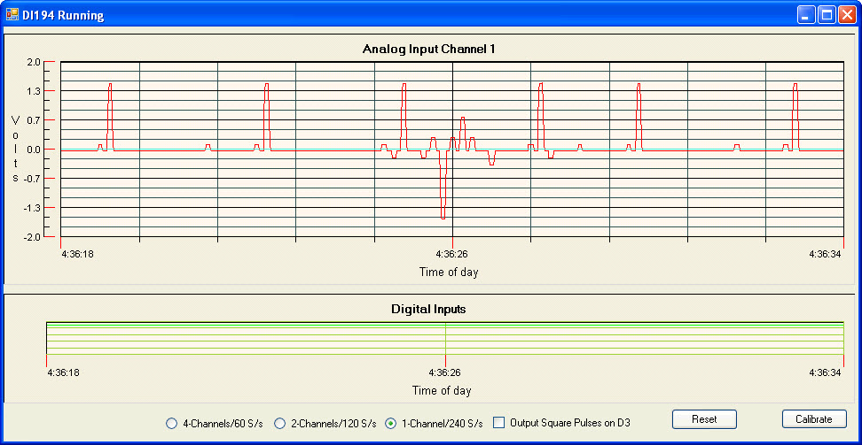
Figure 2. 1-analog channel (240 Hz sample rate)
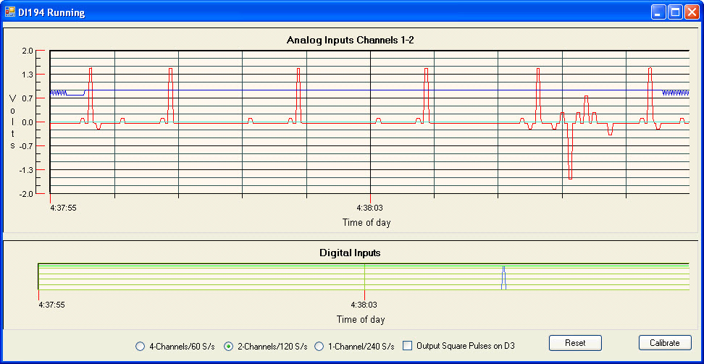
Figure 3. 2-analog channels (120 Hz sample rate)

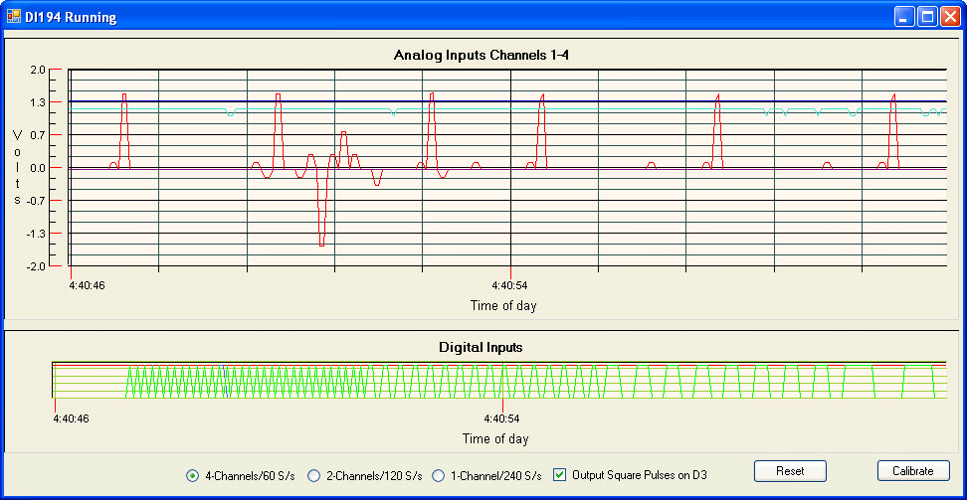
Figure 4. 4-analog channels (60 Hz sample rate)

Limitations
The maximum sample rate is 240 Hz, thus, practical signal analysis from the resulting acquired data is practical up about 30 Hz (Figure 5), though there is some fidelity of 60 Hz data (Figure 6), with aliasing that distorts the oscillographic display. Note the peak amplitude is the same for both 30 and 60 Hz inputs (about 3.6V peak to peak). If you are doing time-domain analysis or display, you should stay away from the 4X Nyquist rate, thus the DI-0194RS probably should be restricted to acquiring data from inputs of 30 Hz or less. If you are doing frequency domain analysis, then you may approach the Nyquist sample rate (with care).
The UI should be updated only occasionally. Changing a plot or graph is a compute intense activity. I refresh the UI approximately twice each second.

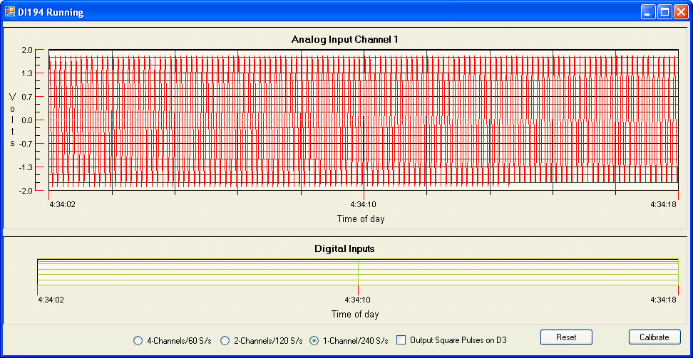
Figure 5. 30 Hz Sinusoidal Input
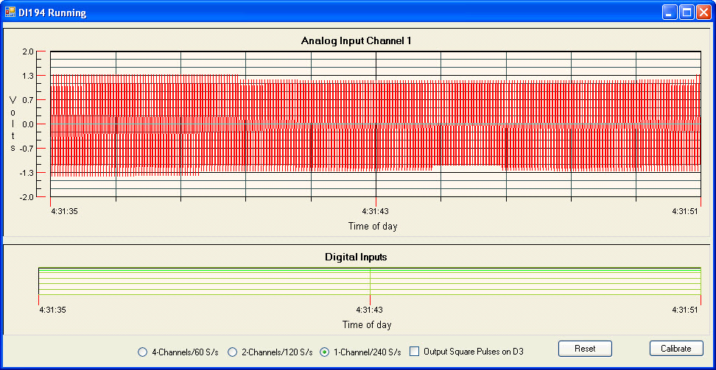
Figure 6. 60 Hz Sinusoidal Input

How About a “Home-grown” display routine?
Figure 7 shows a simple strip chart display that uses no commercial add-ons (native .NET drawing methods).
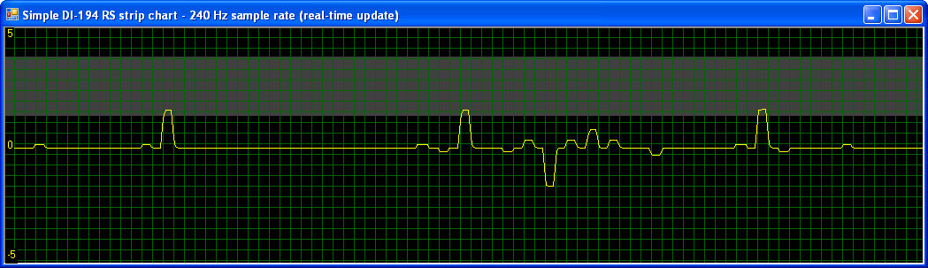
Figure 7. Simple Strip Chart
Compact Framework – Pocket PC and Windows CE Devices
The DI-194RS is port powered; it does not have an independent power supply, but instead gets power (+9V nominal) from the DTR, RTS, and DSR inputs on the RS-232 connector. The serial port on most compact devices is limited to +5V, and the actual current available probably cannot be used to power the A/D. It is quite practical to use a 9V battery and to connect the battery positive terminal to the DTR, RTS, and DSR inputs, while not connecting those same inputs from the Pocket PC or other compact device. Naturally, the battery negative terminal should connect to the RS232 ground, which also is connected between the DI-194RS and the compact device. The Tx and Rx connections will be unchanged. Here is a link to a project where the unit was modified for battery operation (not how I might do it, exactly, but useful): http://www.solid-motion.com/support/pdf/dataq.pdf.
Example Code
The code that I have developed for this project is included on the CD ROM that accompanies my book, Visual Basic Programmer’s Guide to Serial Communications 4.

